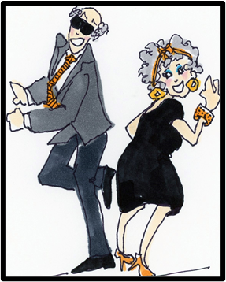

To the class of 1962 from your Reunion Committee

60 Year Reunion, October 20-22, 2022
Here is your Everything-You-Need-to-Know List

2022…Now

Enclosed you will find the following:
- Your Reunion Invitation
- The Registration Form for the reunion and self-addressed stamped return envelope.
Although we have set a deadline of September 8, 2022, it would be very helpful if you could
register well before that.

Please note the following:
- The registration form and payment for the full amount must be mailed to Janie Pierce Shockley. Her address is on the return envelope.
- You will not be considered registered unless you send a check or money order with the form.
- Should you wish to fill out the form on your computer, email Lee for the master form.
- As we have done for our past reunions, we would like to encourage all of you to consider staying at the headquarters hotel.

Headquarters Hotel Information:
- Hilton Garden Inn/University
111 University Avenue
El Paso, TX 79902

- Room rate: $98.00 (Breakfast coupons included)
- Hotel offers free 24-hour shuttle to and from the airport
- Room rate will be honored 3 days prior to and 3 days after the reunion
- You may reserve a room with the Reservation Code only through the phone number or website below:
    - 915 351-2121 or www.elpaso.stayhgi.com
    - Reservation code: EPH62
    - Deadline for special room rate is September 20.

The hotel is situated at the entrance to UTEP. The campus has recently been redesigned and is beautiful. We hope you will take time to walk into the campus to see the changes.

You will have a Trolley ticket in your packet. The trolley runs down to the border and back. You can board the trolley right outside the hotel.

(More on the Reverse)

Activities:

- Friday:
- EPHS Museum/Campus tour (Tentative)
- UTEP Self-tour (Optional)
- Trolley rides to downtown (Optional)
- Friday evening: 6:00-10:00 Mexican Buffet at Lee’s Casa
4304 Donnybrook Place, 79902
Attire: casual
- Saturday:
- EPHS Museum/Campus tour (Tentative)
- UTEP Self-tour (Optional)
- Trolly rides to downtown (Optional)

- Saturday evening: Dinner/Dance at Hilton Inn
    - 6:00 Cocktails
    - 7:00 Dinner
    - 8:00-11:00 Dancing to the music of Louis Imai
    - Attire: Your choice (no shorts or flip flops, please!)

- Sunday morning: No-Host Farewell Breakfast Hilton Inn

See everyone soon!

Questions:
Lee Schwartz: FriedaLee@aol.com (915) 526-2250
Pat Moore: mcpomoore@yahoo.com (915) 780-3890

